2012 DAY FAMILY REUNION
T SHIRT ORDER FORM

This year’s family reunion t-shirts are on sale now. Please fill out this form below and mail it back at your earliest convenience. The Mens Group here in DC will supplement the cost of your t-shirts if you pre-order, thanks to the great fundraisers that we are having, this enables us to share some of the fruits of our success.
PRICES WILL BE:
YOUTH SIZES – Before May 1, 2012 (50% off) $5.50 each After May 1, 2012 (reg. price) $11.00
ADULT SIZES (S-XL) – Before May 1, 2012 (50% off) $5.50 each After May 1, 2012 (reg. price) $11.00
ADULT SIZES (XXL-XXXL) – Before May 1, 2012 (50% off $7.50 each) After May 1, 2012 (reg. price) $15.00
** Orders must be RECEIVED by May 1, 2012 in order for Mens Group to pay half. NO EXCEPTIONS…
YOUTH | AMOUNT
X Small
Small
Medium
Large
ADULT
Small
Medium
Large
X Large
XX Large **
XXX Large **
TOTAL

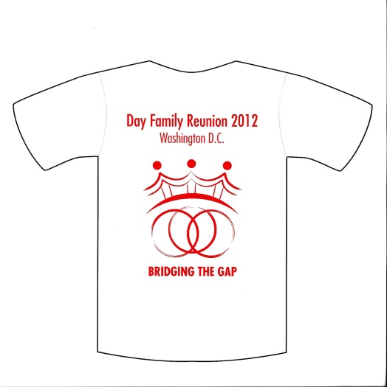

Total Amount enclosed (check or money order) $___________________
Make checks payable to Gil Freeman
Call Donald Jones at 202-321-4840 if need to pay by credit card
Mail to: Gil Freeman P.O. Box 681, Choptico, MD 20621

